

Crop yield monitoring in Eastern Africa

Pilot bulletin for crop prospects in 2003 for evaluation and comments


August 2003
Year 2003, No.6, date 10 September

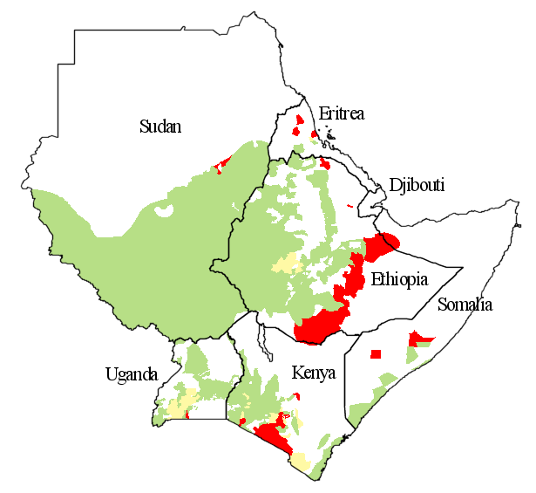


MAIZE AND SORGHUM YIELD PROSPECTS ARE BETTER THAN IN 2002

Although the cumulated rainfall for the current crop season stays below normal (mainly for Ethiopia, Kenya and Uganda) an improvement of the crop conditions for maize and sorghum was observed.

Maize

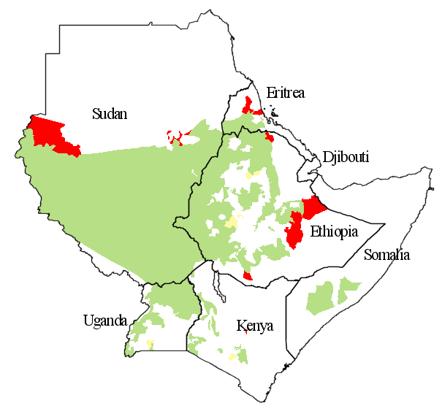

The maize yield estimated up to the third dekad of August is overall higher than the 2002 yield for the whole region, due to a better rainfall distribution (Figure 1).

In general the current crop season is near 85% of the total maize crop cycle length for the three main producer countries: Uganda, Kenya and Ethiopia (Figure 4). Yield reduction is estimated in: South Buganda in Uganda where the main crop season is over, Kajiado and Taita Taveta in Kenya and southeastern part of Oromiya, Somali and Tigray in Ethiopia.


Sorghum
Crop failure or very poor yield
More than 10% WRSI reduction compared with 2002
Better or equal yield than 2002 and no crop failure

Sorghum is developing well and has good yield prospects for three main producer countries: Sudan, Ethiopia and Uganda. For Sudan and Ethiopia the current crop season is near 50% of the total sorghum crop cycle length. In Kenya and Somalia the main crop season is over and in Uganda almost. For Somalia yield is expected close to average.
Figure 1. Maize: Some areas with low yield are forecasted mainly for South Buganda in Uganda, Kajiado in Kenya and southeastern Oromiya in Ethiopia. Good maize yields are estimated for Gambela, Southern and northwest part of Oromiya in Ethiopia and southern Somalia. Sorghum: In general, sorghum is developing well in the region. Low yield are forecasted mainly for northwest part of Oromiya in Ethiopia, Anseba in Eritrea, and Western Darfur and southern part of Northern Darfur in Sudan.

Rainfall analysis

The difference between current and normal cumulated rainfall is presented in the map, Figure 2.

The graphs in Figure 2 represent the comparison between cumulated current rainfall and cumulated normal, spatially averaged by country taking in consideration only the areas planted with maize and sorghum.

Rainfall is below normal in major areas of Ethiopia, Uganda and Kenya. Also, rain is below normal in the southwestern part of Sudan.

Vegetation index analysis

The difference in the vegetation index (NDVI) between the third dekad of August 2003 and the same dekad of the previous year shows some spots with negative differences in: western Ethiopia and southeastern Sudan. (Figure 3, Page 4).

The negative differences observed are linked with the irregular rainy season.
The JRC, in collaboration with FAO is pleased to present this issue of “Crop yield monitoring in Eastern Africa” for the 2003/04 crop season.

MARS-FOOAID will provide regular monthly updates on the progress of the 2003/04 crop season. The bulletin will be available in the “Crop and Rangeland Monitoring Network for the Greater Horn of Africa”: http://marsunit.jrc.it/Africa/ or ftp://mars.jrc.it/bulletin/EasternAfrica. Also MARS-FOODAID crop monitoring products will be available through the JRC Digital Map Archive: http://dma.jrc.it.

Another useful product for Somalia is available on: ftp://mars.jrc.it/Bulletin/Somalia

Comments and remarks for improvement of this pilot bulletin are welcome.
The South of Somalia presents a slightly better NDVI profile than the previous crop season (more detail about crop situation in Somalia on ftp://mars.jrc.it/bulletin/somalia).

Crop water requirement

Figure 4 and 5 (Page 5 and 6) show the Water Requirement Satisfaction Index (WRSI), obtained by using the FAO Crop Specific Water Balance (CSWB) model.

Both Figures represent a forecast of WRSI for maize (Figure 4) and sorghum (Figure 5) at the end of the growing season. Long-term average climatological data are used to calculate WRSI for the period between the current dekad and the end-of-season.

The yield prospects for maize are not good in southwestern Oromiya in Ethiopia, South Buganda in Uganda and Kajiado, Taita Taveta and Narok in Kenya. For the rest of the region the yield is forecasted to be higher than 2002 crop season.

In the case of sorghum, the situation seems clearly much better than 2002 crop season. But the final result will depend on the rainfall progress during the next months; mainly in Sudan and Ethiopia. Low yield is forecasted principally for the northwestern part of Oromiya in Ethiopia, Anseba in Eritrea, and Western Darfur and the southern part of Northern Darfur in Sudan.

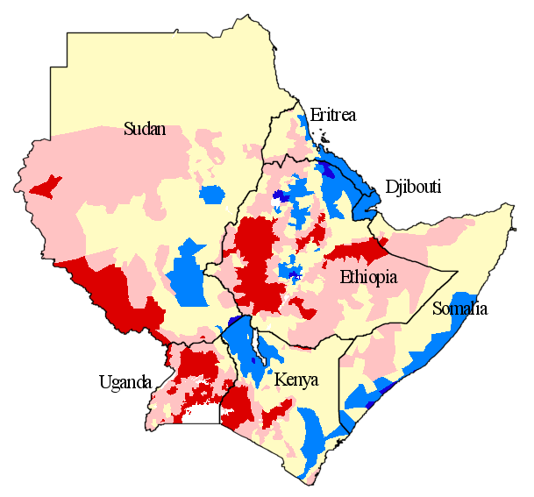
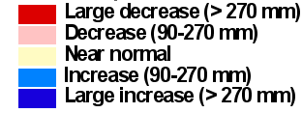
Figure 2. Rainfall difference with the cumulated normal up to the 3rd dekad of August 2003. Data are derived from the ECMWF model. Cumulated actual rainfall compared with normal in the graphs was spatially-averaged taking in consideration only the areas cultivated with maize and sorghum.

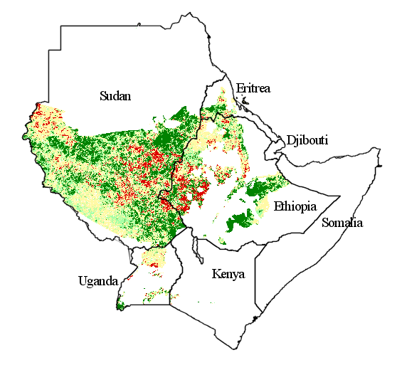
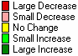
Vegetation difference (2003-2002)
Figure 3. Normalized Difference Vegetation Index (NDVI). Absolute difference between the third dekad of August 2003 and the same dekad of the previous year. The areas that did not plant sorghum and the areas in which the crop cycle is completed, have been masked-out.
Crop cycle length
Figure 3. Normalized Difference Vegetation Index (NDVI). Absolute difference between the third dekad of August 2003 and the same dekad of the previous year. The areas that did not plant sorghum and the areas in which the crop cycle is completed, have been masked-out.

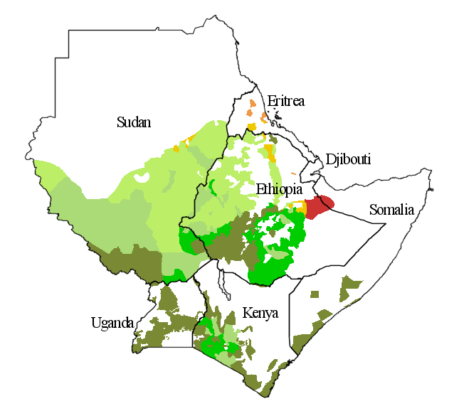
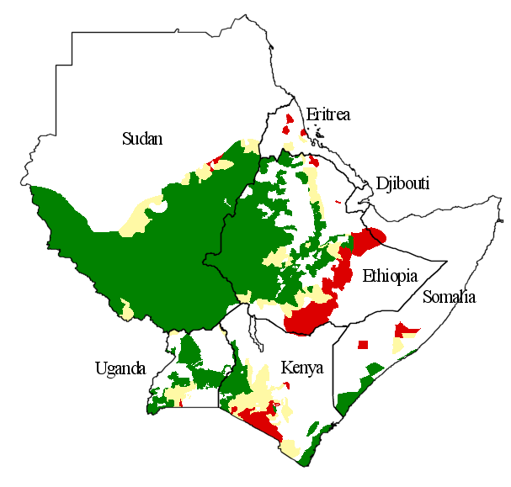
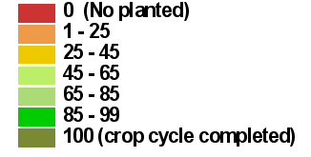
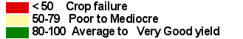
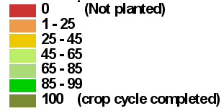
Crop cycle progress index
WRSI Maize
Figure 4. Water Requirement Satisfaction Index for maize 2003 (Map central) and comparison between WRSIs 2002 and 2003 (Bar graph). For the whole region the situation of the rain-fed maize is better than 2002. In the areas where the length of maize cycle is not completed normal rainfall was used to obtain the final value of WRSI. For these areas the WRSI values have to be considered as an early forecast of the crop yield situation ( see Crop cycle progress index). The areas not planted at this time of the crop season are considered as a crop failure.

Figure 4. Water Requirement Satisfaction Index for maize 2003 (Map central) and comparison between WRSIs 2002 and 2003 (Bar graph). For the whole region the situation of the rain-fed maize is better than 2002. In the areas where the length of maize cycle is not completed normal rainfall was used to obtain the final value of WRSI. For these areas the WRSI values have to be considered as an early forecast of the crop yield situation ( see Crop cycle progress index). The areas not planted at this time of the crop season are considered as a crop failure.

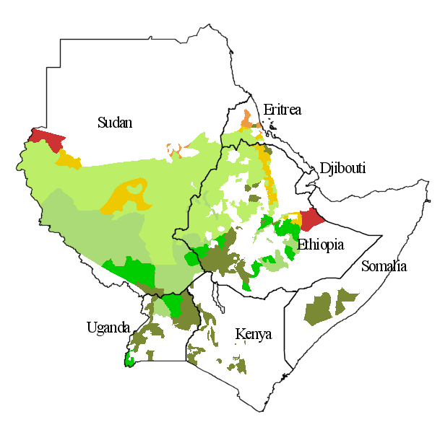
Crop cycle progress
Crop cycle progress

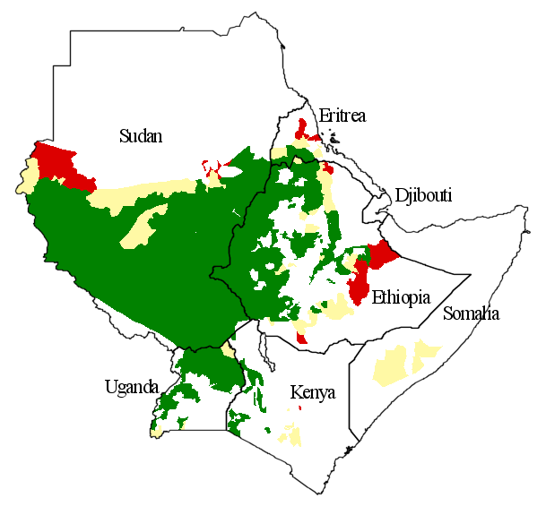
WRSI Sorghum
Figure 5. Water Requirement Satisfaction Index for sorghum 2003 (Map central) and comparison between WRSIs 2002 and 2003 (Bar graph). For the whole region the situation of the rain-fed sorghum is better than 2002. In the areas where the length of sorghum cycle is not completed, normal rainfall was used to obtain the final value of WRSI. For these areas the WRSI values have to be considered as an early forecast of the crop yield situation (see Crop cycle progress index). The areas not planted at this time of the crop season are considered as a crop failure.

